**IT Workshop 2**

**Project Report**

**On**

**“College Management App”**

***Contributors***

**Amit Prajapati BT20ECE102**

**Chaitanya Pawar BT20ECE093**

**Vinaykumar Zine BT20ECE080**

**Guddu Kumar BT20ECE090**

**Hari Krishna Rathod BT20ECE079**

**Gaurav Khirade BT20ECE089**



**Guided By :- *Dr. Shishupal Kumar Sir***

***Mr. Gaurav Balwantrao Malode Sir***

***Flutter Widgets***

**Widgets** are the central class hierarchy in the Flutter framework. A widget is an immutable description of part of a user interface. Widgets can be inflated into elements, which manage the underlying render tree. Widgets themselves have no mutable state (all their fields must be final).

Some of the important widgets used in this project are as follows:-

* **Appbar** : AppBar is a material widget in flutter which is most commonly used in almost all kinds of applications. Appbar will display the toolbar that we see in every application.
* **Scaffold**: Scaffold is a class in flutter which provides many widgets or we can say APIs like Drawer, SnackBar, BottomNavigationBar, FloatingActionButton, AppBar etc. Scaffold will expand or occupy the whole device screen. It will occupy the available space.
* **Material App**:- MaterialApp is an extension of the generic top-level widget provided by Flutter: WidgetsApp . WidgetsApp is a convenience widget that abstracts away a number of features required for most mobile apps, such as setting up a navigator and using an app-wide theme.

**Register Form**

The Register Form is created with various flutter widgets .The Register form asks the user to enter the following credentials :-

* E-mail
* Password
* Confirm Password

The feature of hiding/showing password is also made available in the form of an “eye” symbol.

After this, the user is asked to select his/her identity from the drop-down list.

Upon clicking on the “Login” button, the “Login” screen appears.

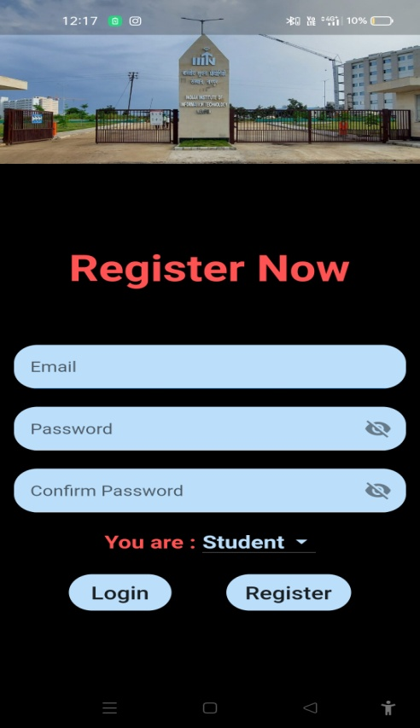 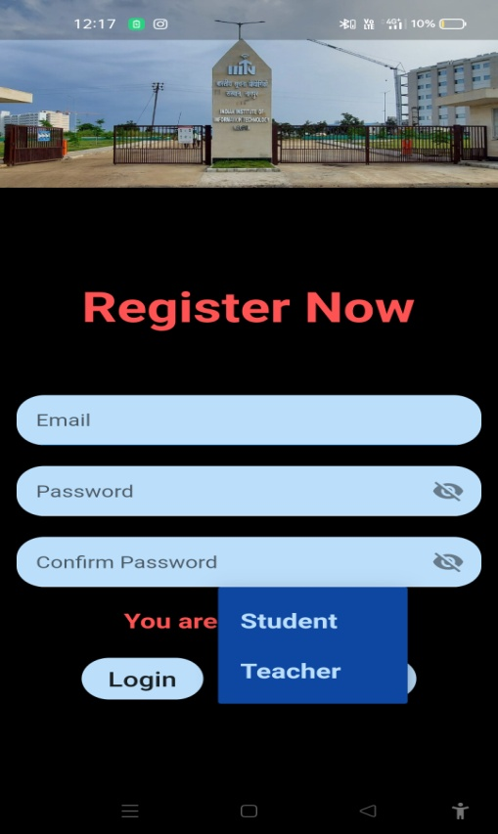

**Login Form**

The login screen has been built with various Flutter widgets. First there is a widget for the company/organization/app name. Then about the screen itself, Sign in. Now, we have two text fields, user name and password, to get login/sign-in credentials from user. Then we have a [TextButton widget](https://www.tutorialkart.com/flutter/flutter-textbutton/) for the Forgot Password. After that, there is an [ElevatedButton widget](https://www.tutorialkart.com/flutter/flutter-elevatedbutton/) for the Login button. If the user does not have an account, there should be a provision for the Sign-up process, hence a Sign-up TextButton.

**Login Form**

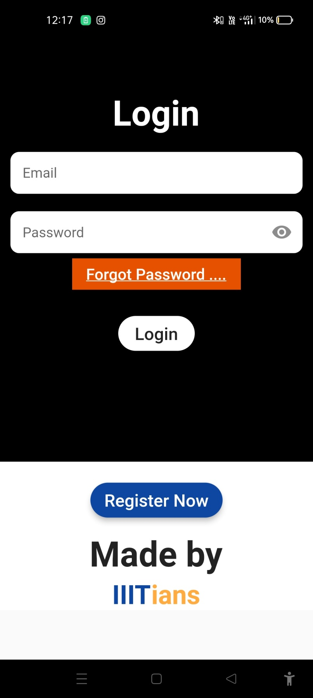

**Forgot Password**

After clicking on the “Continue” button ,new page appears,namely “Forgot Password”. It basically asks the user to enter the registered email account, so that password can be reset with few other steps.

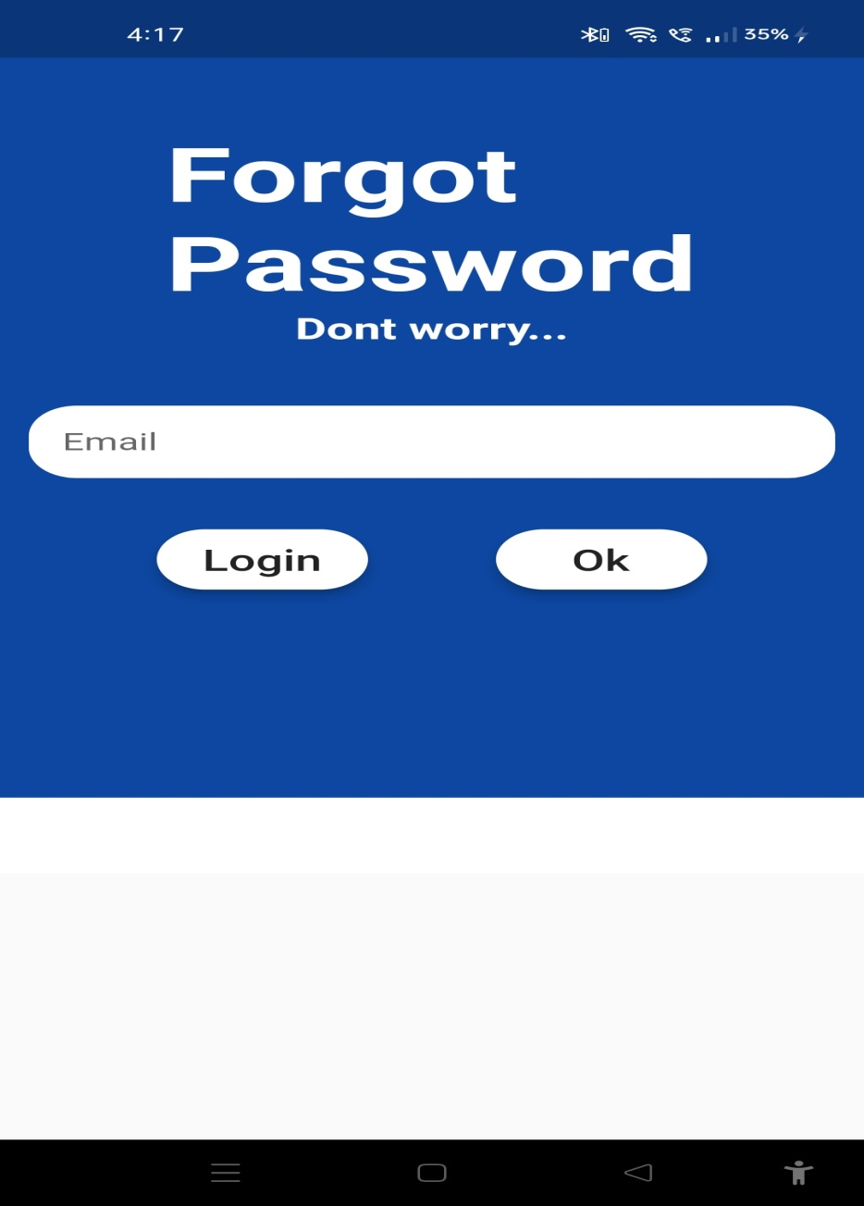

**Teacher (Admin Page)**

Using various flutter widgets, we’ve created our “Teacher” in which following features have been specified :-

* Two buttons have been created namely, “List of Students” and “Post”.
* On clicking the “List of Students” button, the page of “Students” appears.
* On clicking the “Post” button, the page of “Post” appears.

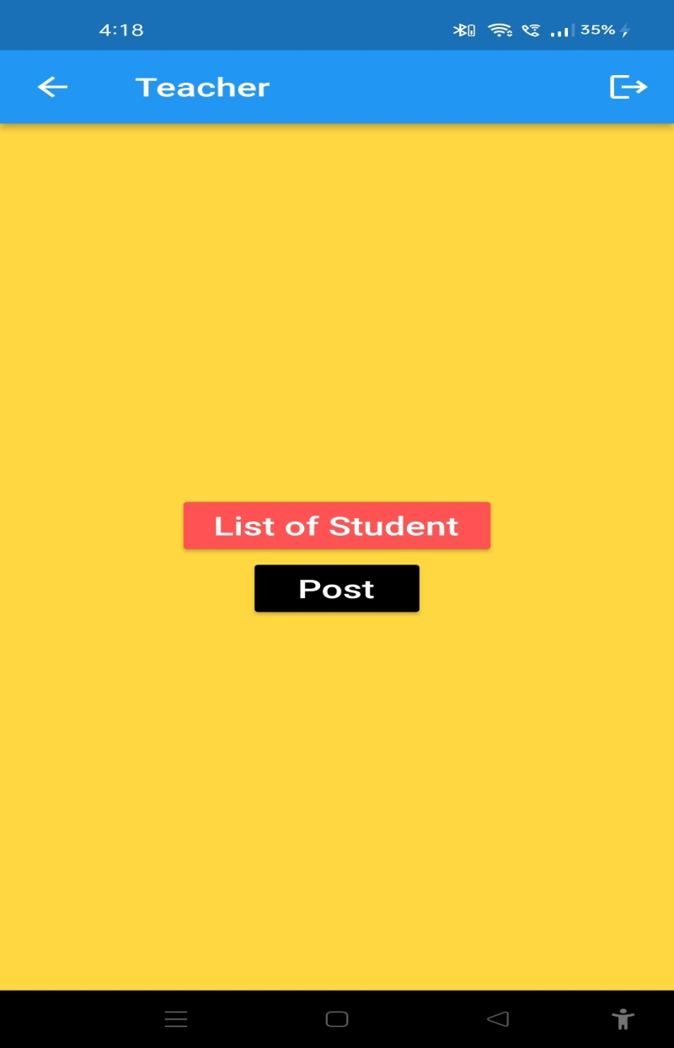

**Students**

In this activity page, the list of all the students who have been enrolled/registered in the college can be seen in the form of their of email id.

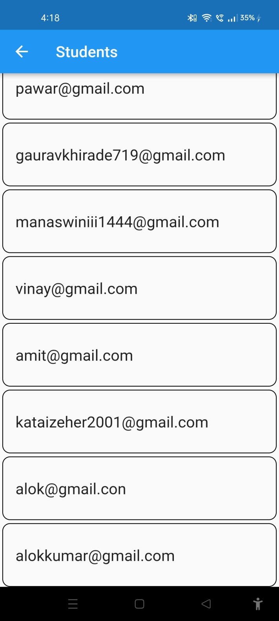

**Teacher Post**

After clicking on the “**Post**” button in the “**Teacher**” page, the “**Post**” activity page appears, which is equipped with the following features :-

* It contains the notices/messages posted by the teacher earlier.
* A “**Create New Post**” feature ( represented by ‘+’ symbol ) is provided at the bottom-right of the page ,which upon clicked renders a page in which new post can be created.

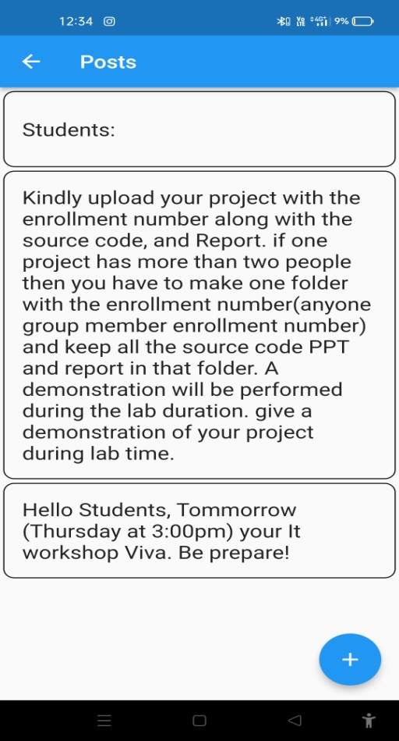 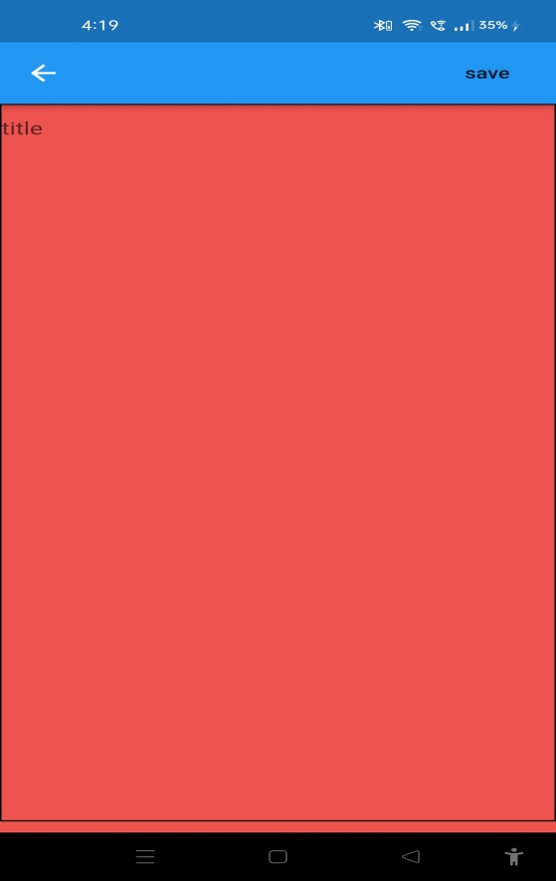

**Student’s Post**

This new post created is then gets rendered on the Student’s activity page where they can view this post.

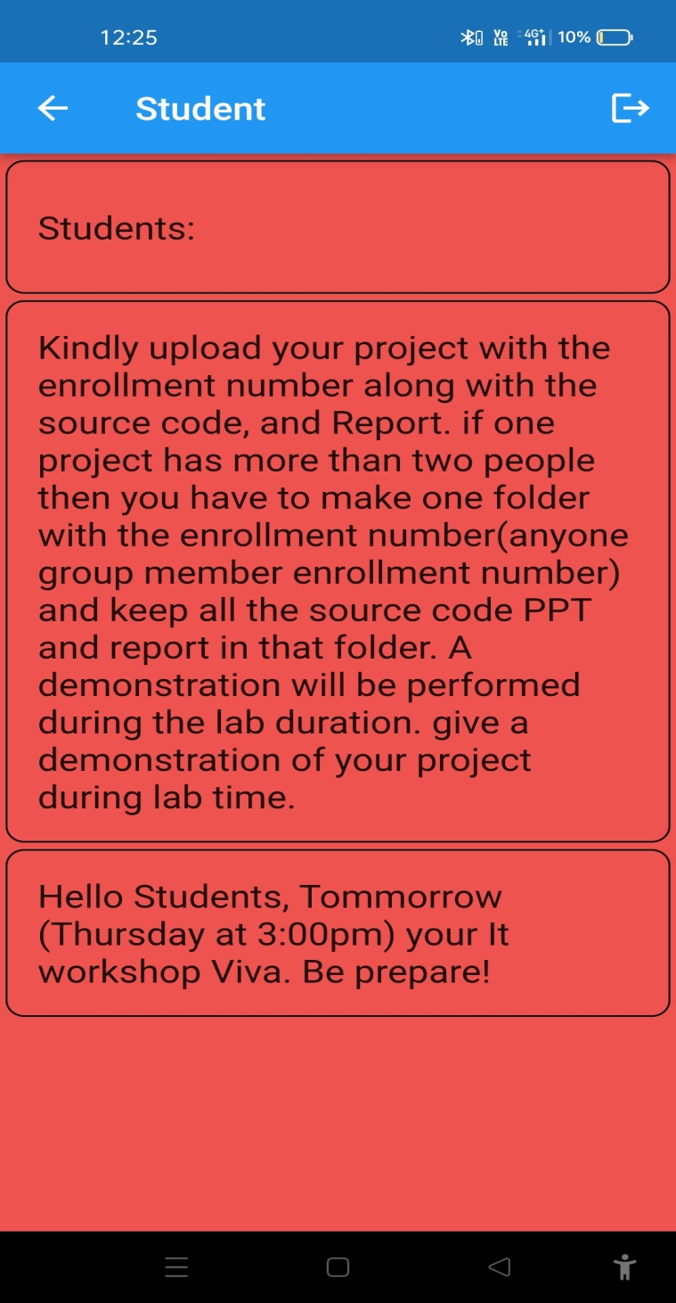

Thank You